### **PROJECT REPORT**

### (Data Literacy with Tableau)

**TITLE: ESTIMATION OF BUSINESS EXPENSES**

1. **INTRODUCTION** 
   1. **Overview**

Estimation of business expenses involves predicting and planning for the costs a business is likely to incur in its operations. Here with this project of **“DATA LITERACY WITH TABLEAU**” we have created this report. The process typically includes forecasting various expenditures such as salaries, utilities, raw materials, rent, marketing, and other operational costs. Businesses use historical data, market analysis, and industry benchmarks to make informed estimates. Accurate expense estimation is crucial for budgeting, financial planning, and ensuring the business operates within its means, leading to sustainable growth and profitability.

* 1. **Purposes**

Estimation of business expenses is a fundamental aspect of financial management. It empowers businesses to plan, control costs, make strategic decisions, manage cash flow, and ultimately achieve sustainable growth and profitability. And working with **Tableau** has many aspects of improving the visualisation techniques.

1. **PROBLEM DEFINTION AND DESIGN THINKING**
   1. **Empathy Map**

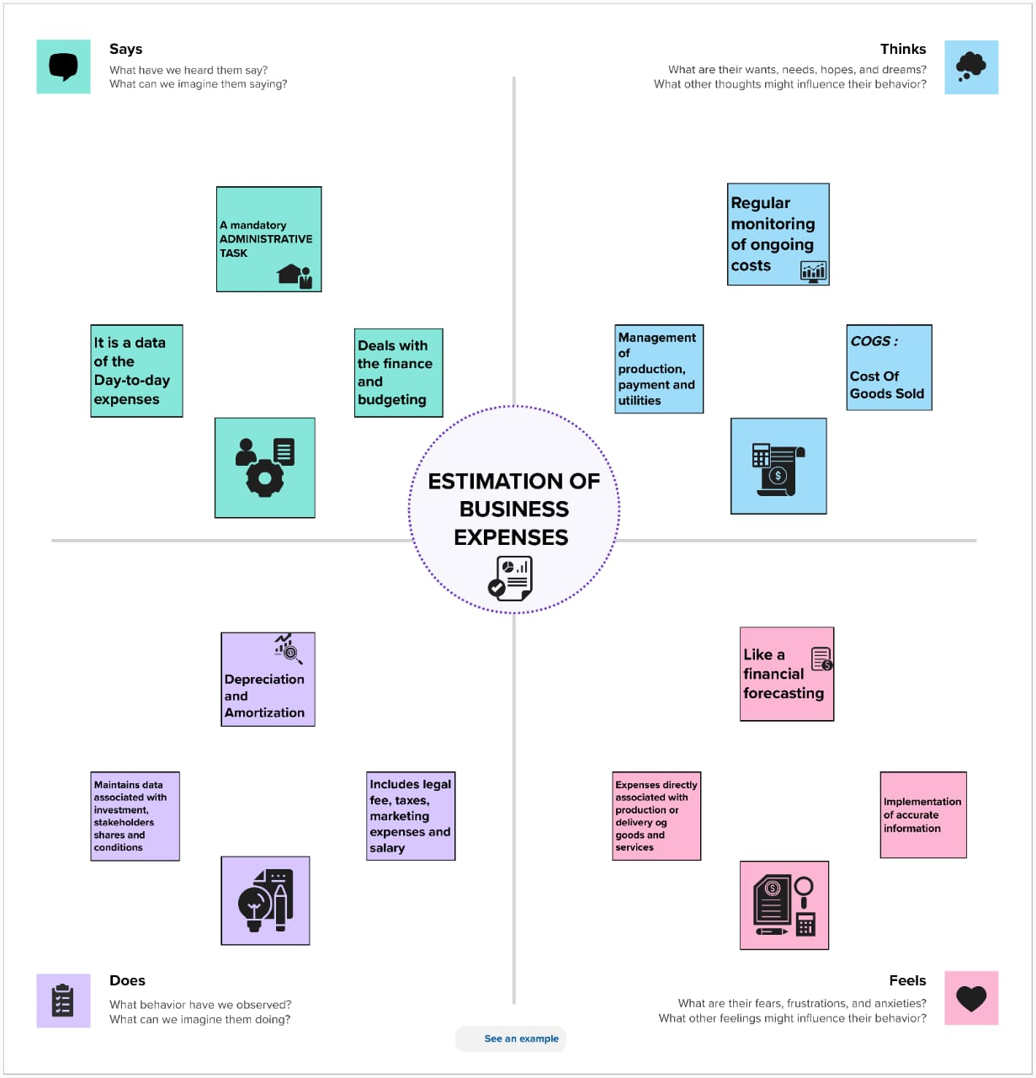

**2.2 Brainstorming and Ideation**

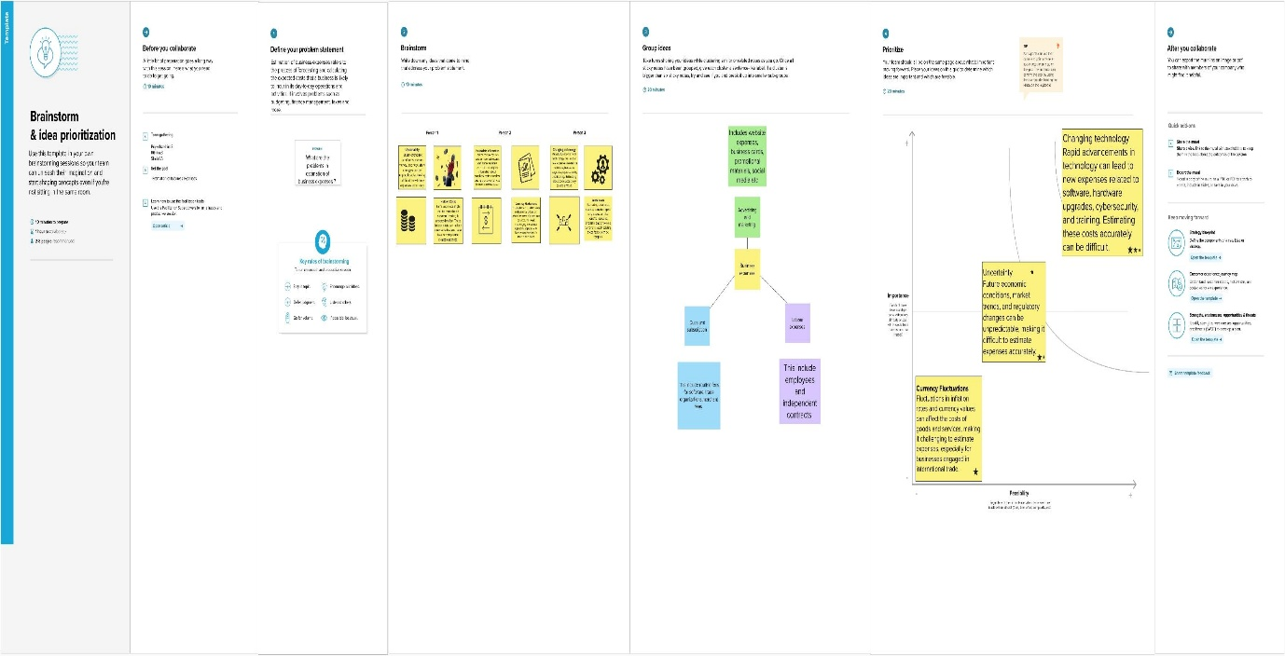

1. **RESULT:**

**Dashboard 1**

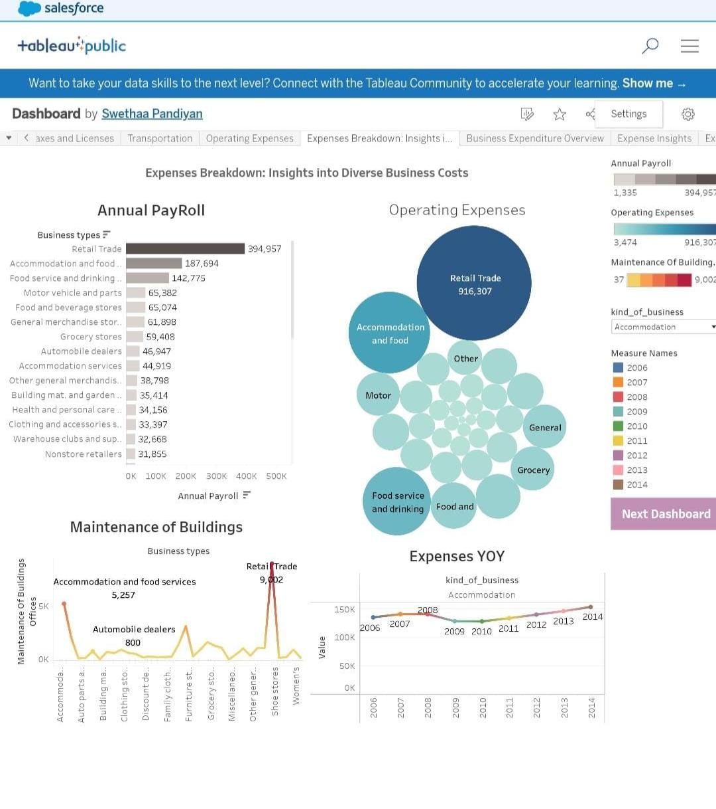

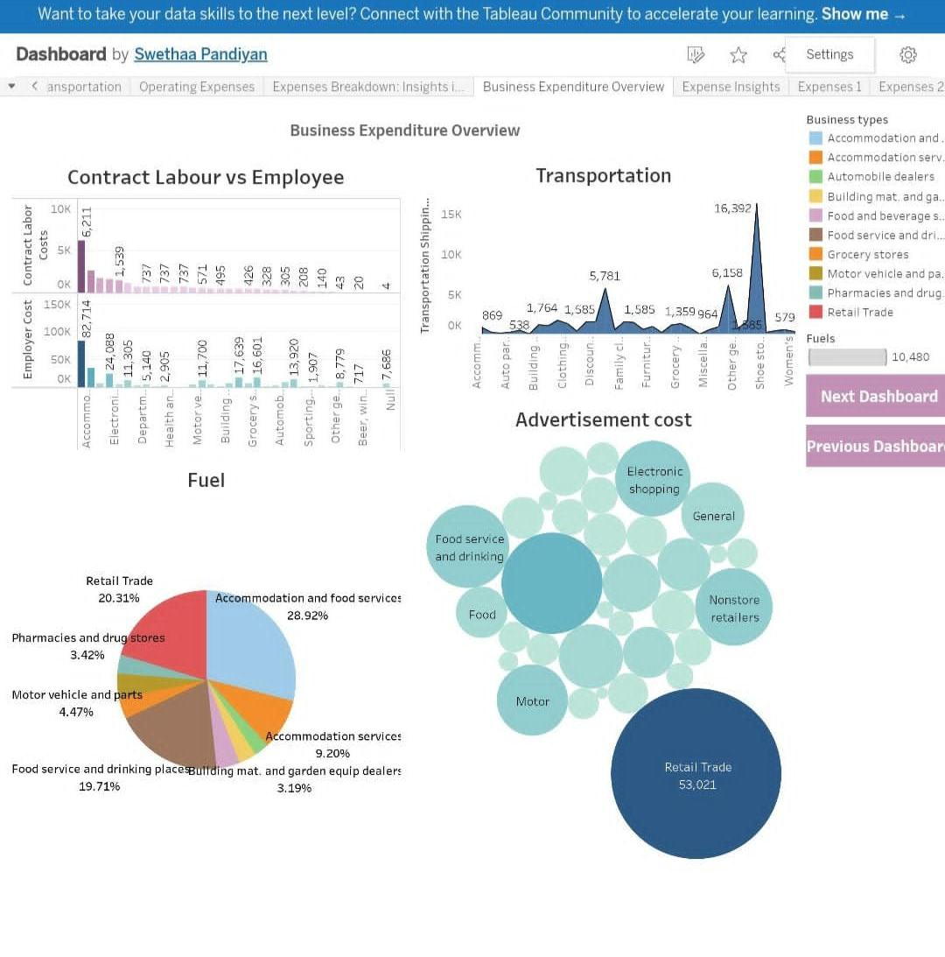 **Dashboard 2**

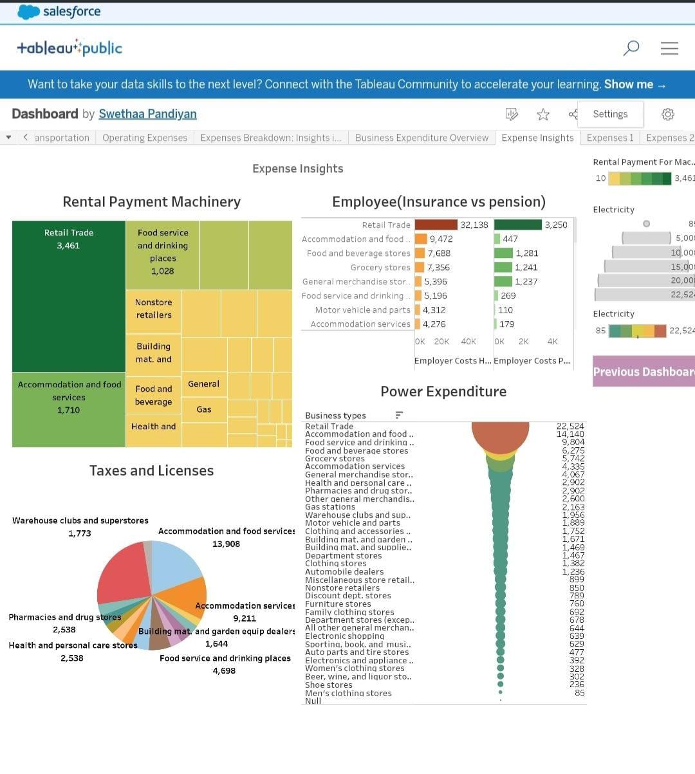 **Dashboard 3**

**Story 1**

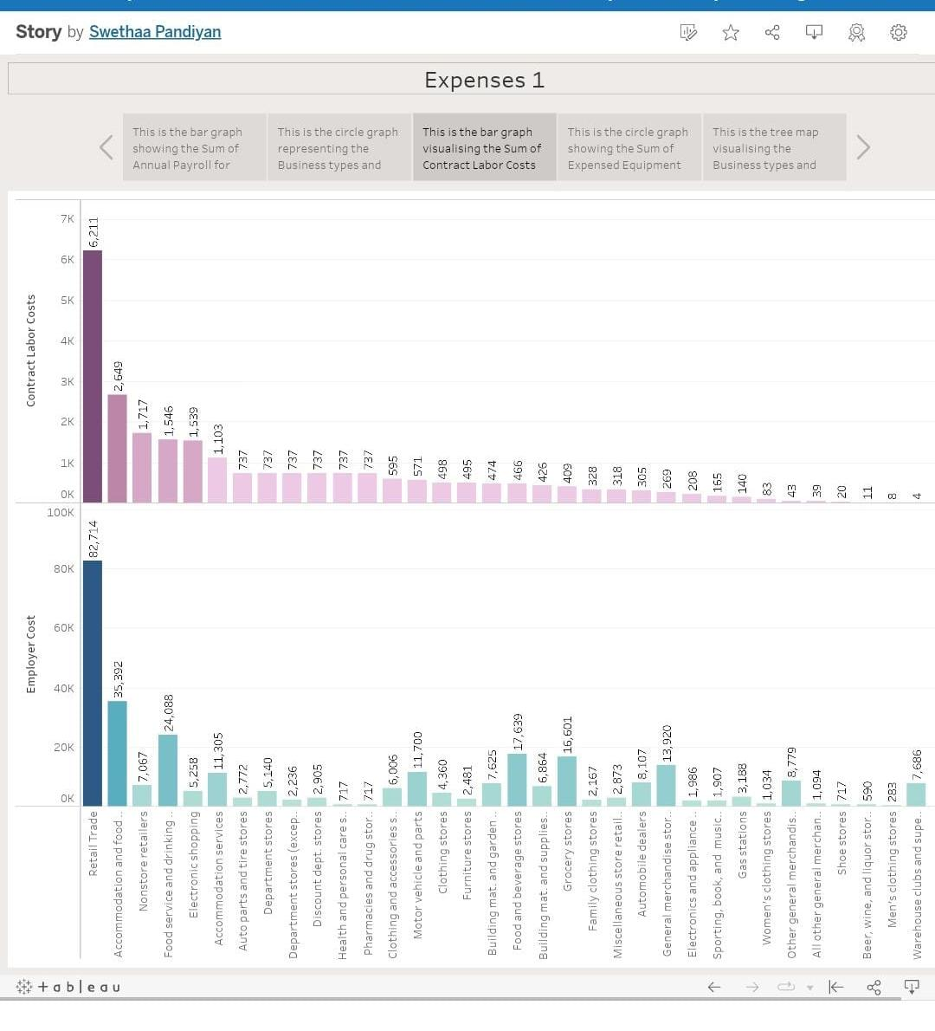

**Story 2**

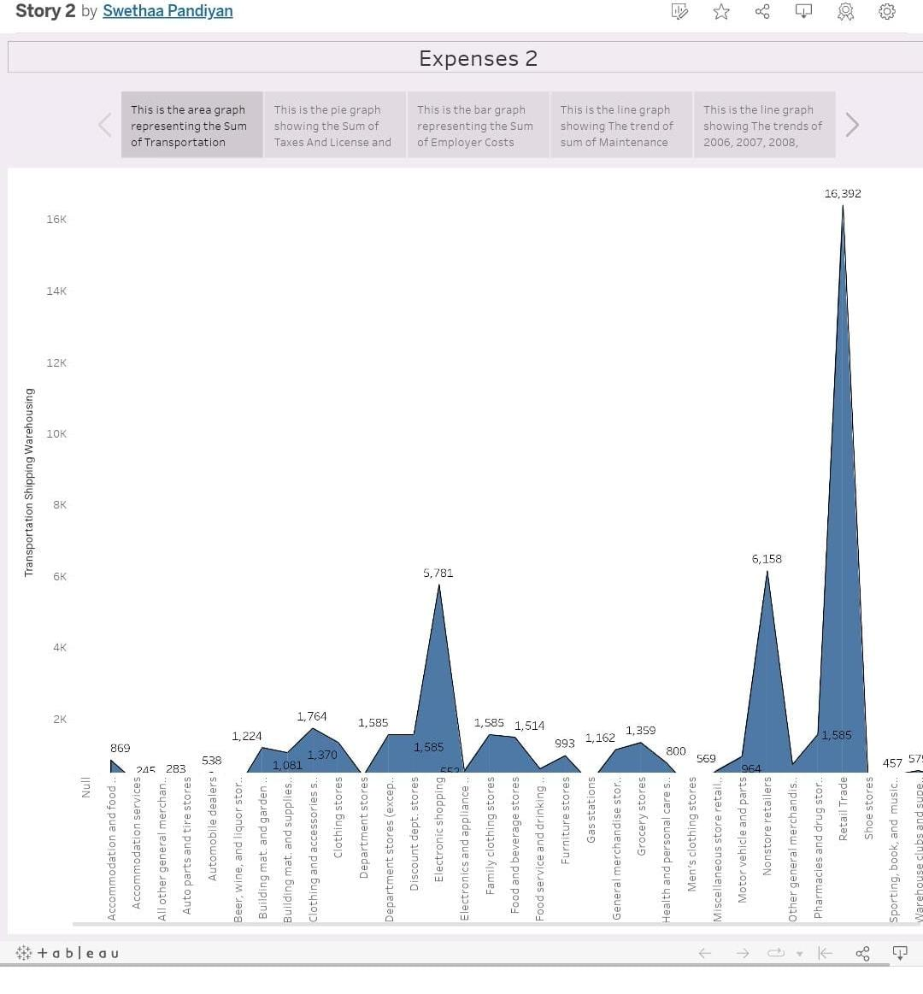

1. **ADVANTAGES AND DISADVANTAGES**

**ADVANTAGES:**

* Financial Planning:
* Costs
* Data visualisation techniques
* Profitability Analysis: Allows accurate calculation of profits for evaluating financial health.
* Business expenses management, Financial services, Budgeting.

**DISADVANTAGES**

* Uncertainty
* Inaccuracy
* External Factors
* Time and Effort

1. **APPLICATIONS:**

Estimation of business expenses is applied in:

* Financial Planning
* Decision-Making
* Cash Flow Management
* Resource Allocation and further data analytics
* Performance Evaluation with self analysing
* Risk Management
* Compliance

1. **CONCLUSION:**

The estimation of business expenses is a critical process that plays a fundamental role in the financial management of organizations. By accurately predicting future costs, businesses can plan their budgets, make informed decisions, manage cash flow, allocate resources effectively, and evaluate their performance. However, it is essential to acknowledge the inherent uncertainties and potential inaccuracies in the estimation process. Despite these challenges, we have tried our best in implementing the project report with the ideas of our team members.

1. **FUTURE SCOPE:**

The future scope for estimation of business expenses involves advancements in technology such as data analytics, automation, and predictive algorithms. Integrating with enterprise systems, real-time expense tracking, scenario planning, and the use of blockchain technology are expected to enhance the accuracy and efficiency of expense estimation.